GL 121 Cheat Sheet
General rules:
- These screens are read only, so feel free to play around on these screens.
- If you need to move to a previous screen, you will use either F12 or F3.
- If you hear a “pinging” sound, you hit a key the green screen did not recognize, simply hit the “Ctrl” button. You may then perform whatever function you need to.
- There will be function keys at the bottom of the screen to assist you in navigating these screens. (any function after F12 is achieved by hitting shift – for example, F13 is shift F1, F14 would be shift F2, so on so forth.)
In the green screen, enter “GL121”. You should receive a screen similar to this.
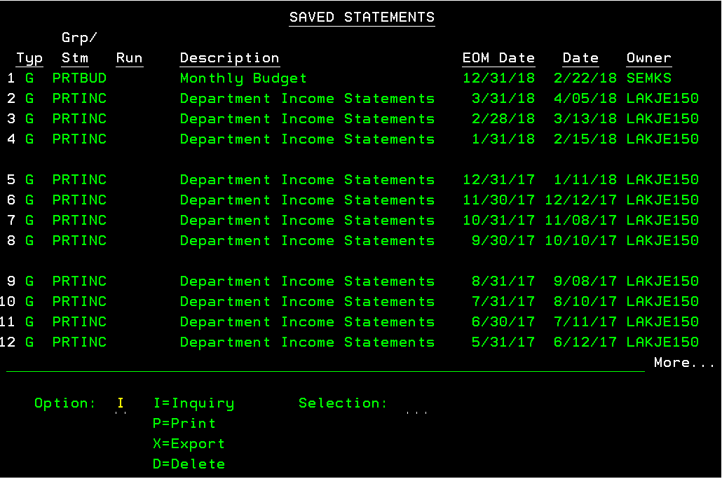
You should see ‘Department Income Statements’ for each respective month. The “EOM Date” is the report date. The “Date” is simply the date the report was generated.
From here, you may select inquiry (I) to drill down to further detail or print (P) to print the statement. You may print to a printer (this should be the default) or you can have it emailed to you (command in the Outq/Printer is EMAIL2TXT or EMAIL2PDF). Selection is whichever month you so choose.
You should receive a screen listing your department similar to the following snip. This will list all departments you have access to.
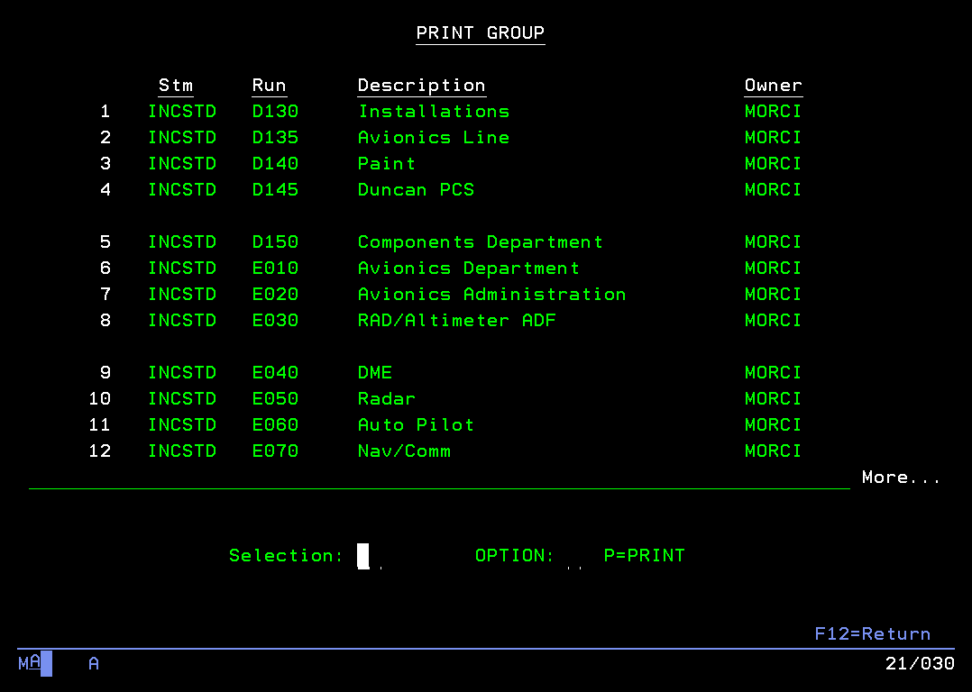
If you do not see the department you are needing access to, have your manager request access for you to LNK Help Desk and Paul Schlorholtz, Controller. The access must be approved by the manager and reviewed by the Controller prior to approval.
From this screen, you may print that department, otherwise, you may use the selection to view the income statement on screen for whichever department you select, which has many benefits.
Once selected, you should receive the following screen.
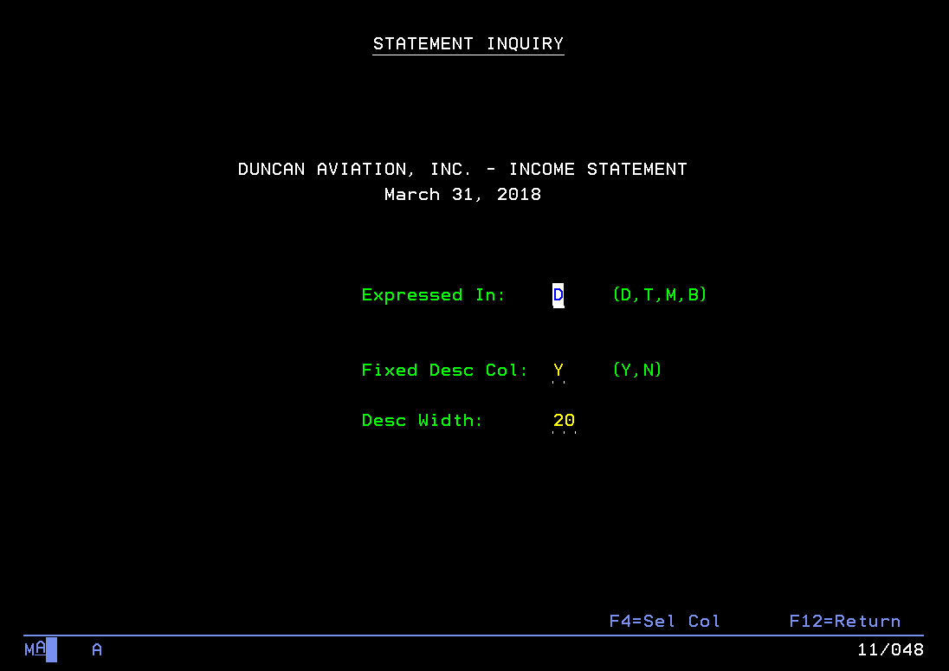
You may simply click enter on this screen, no changes need made here.
You should be on the following screen showing the income statement at this point.
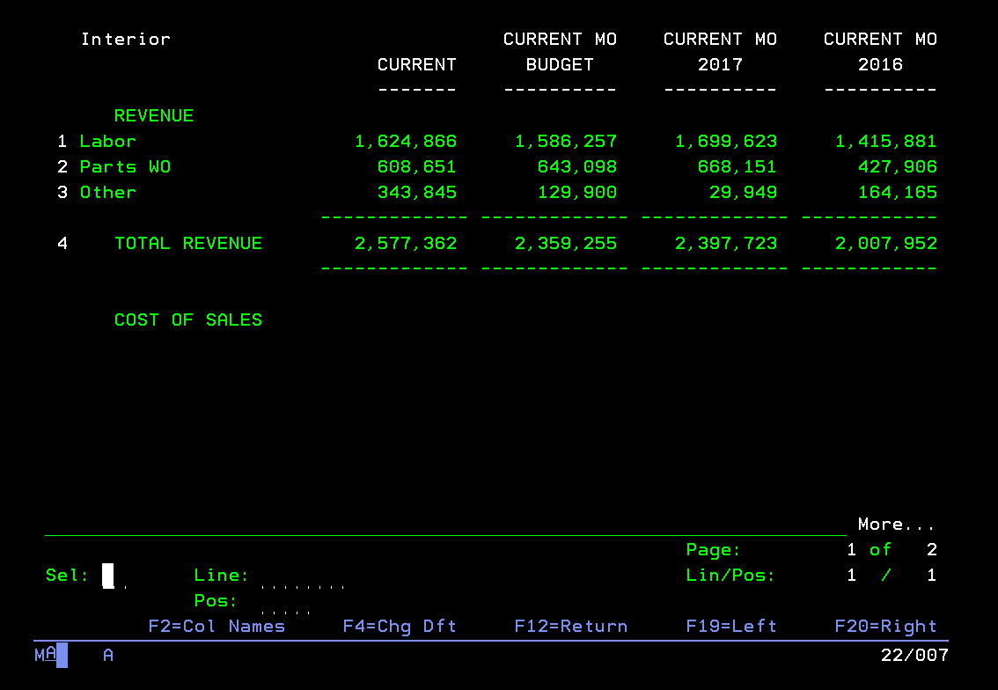
The bottom left is the 3 areas you will use to navigate this screen.
Line: Moves you up and down on your income statement. For example, if I put 40 in the “Line:”, this will move you to the beginning of expenses. If you put 10 in the “Line:”, this will move you to Cost of Sales. You may also use the page up and page down function buttons to accomplish the same thing.
Pos: Moves you left and right on the income statement. More often than not, you will probably only need the current month and current month budget, but you may wish to see YTD, etc. Same theory here, if you put in 57, you can see the YTD, YTD Budget, YTD 2017, and YTD 2016. You may also use F19 (left) and F20 (right) to move through the income statement.
Sel: The selection button is important here. It will give you detail, by account number, into what is behind the monthly results. If you select any line item, you would receive the following screen. (I moved down to expenses, using the “Line:” and selected office supplies.)
**Feel free to play around with these, you cannot hurt anything here. Remember, if you hear a pinging sound, hit “Ctrl”.

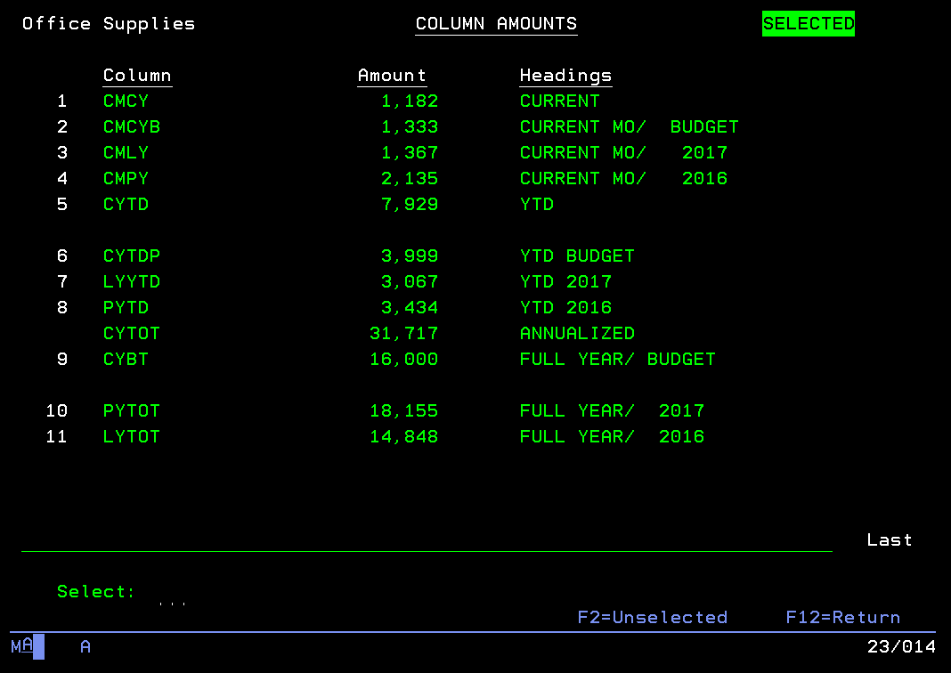
The selections here are the headings on your income statement (CMCY – current month current year, CMCYB – current month current year budget, etc.). You will generally want to select 1 here for the current month. You may also select year to date detail by selecting 5.
Remember, we budget at a financial statement line item, so there will generally be no additional drill down on the budget.
This will give you the following screen.
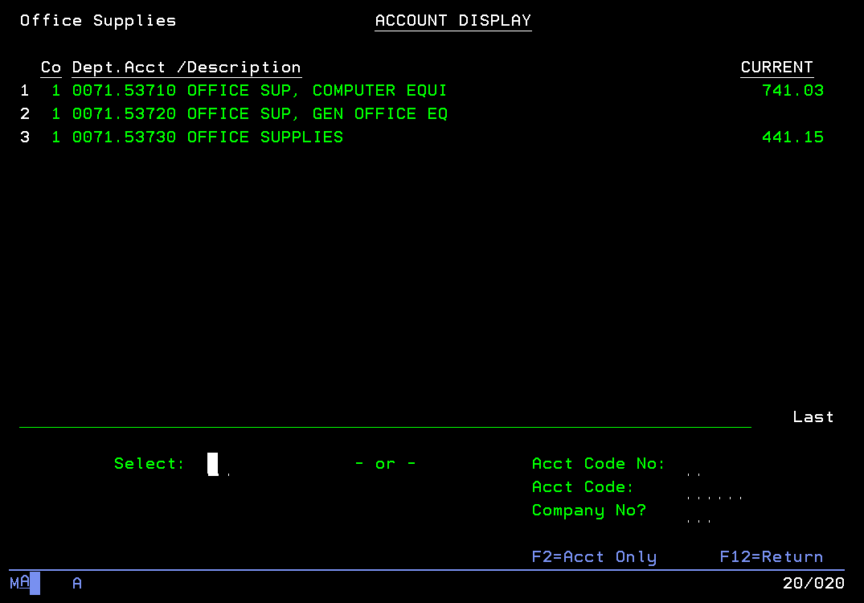
This lists all accounts that build into that office supplies expense line item that you selected. This works for ALL line items on the income statement. If you had selected another expense line on your income statement, it would list all accounts that build up into that financial statement line item.
Once again, feel free to play around with these screens, you can’t hurt anything.
From here, you can select the account. So I selected 3 and received the following screen.
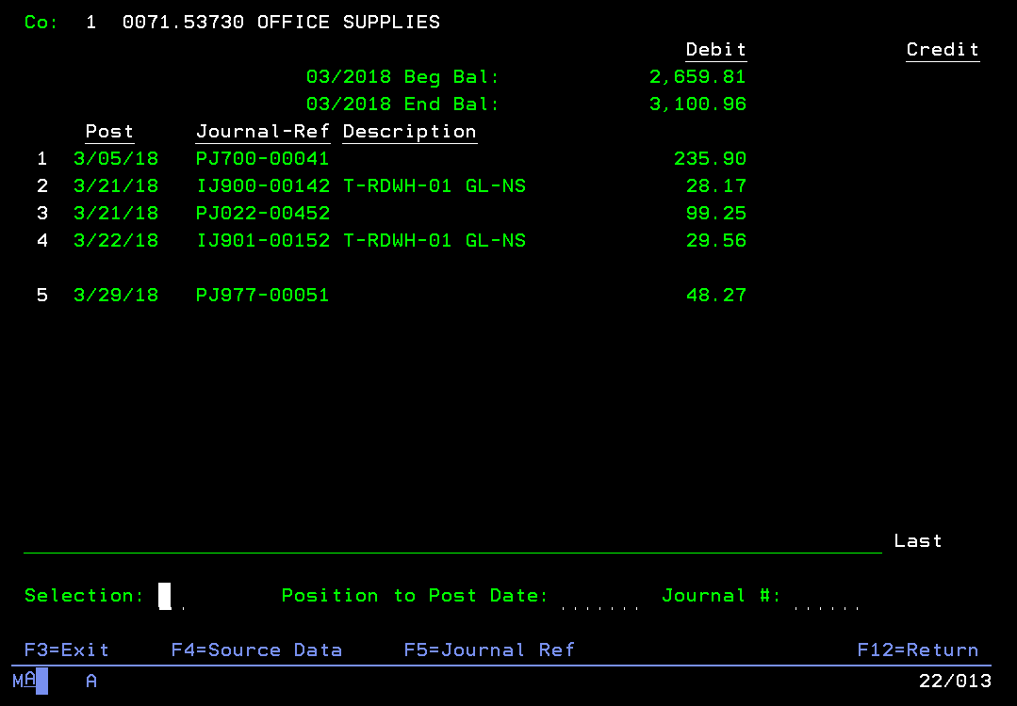
This is the “GL10” screen. This gives you detail by account (0071 is the department that we are in and 53730 is the particular account). You may select whatever line you want. Hit F4 for detail.
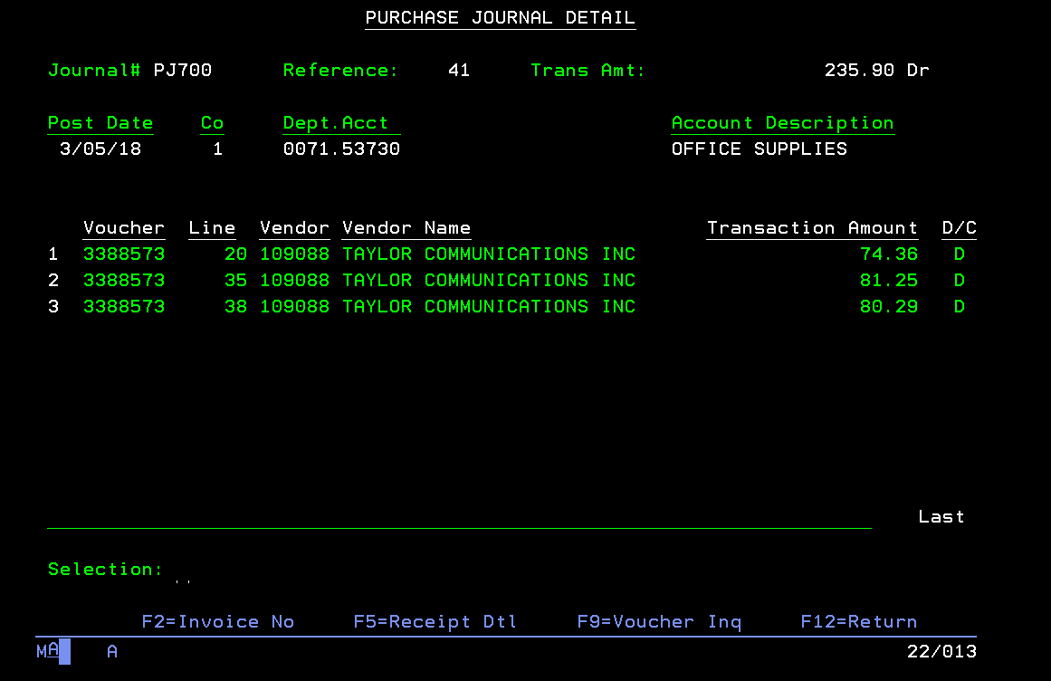
From here, you will SOMETIMES be able to select whichever line and hit enter for more detail. If you are on this particular screen, you will have to select a line and use the function keys (noted at the bottom of the screen) for more detail. If you select 1 and hit F2, it would give you the invoice number. You can also use F5 and F9.
F2 yields this screen. F9 yields this screen.
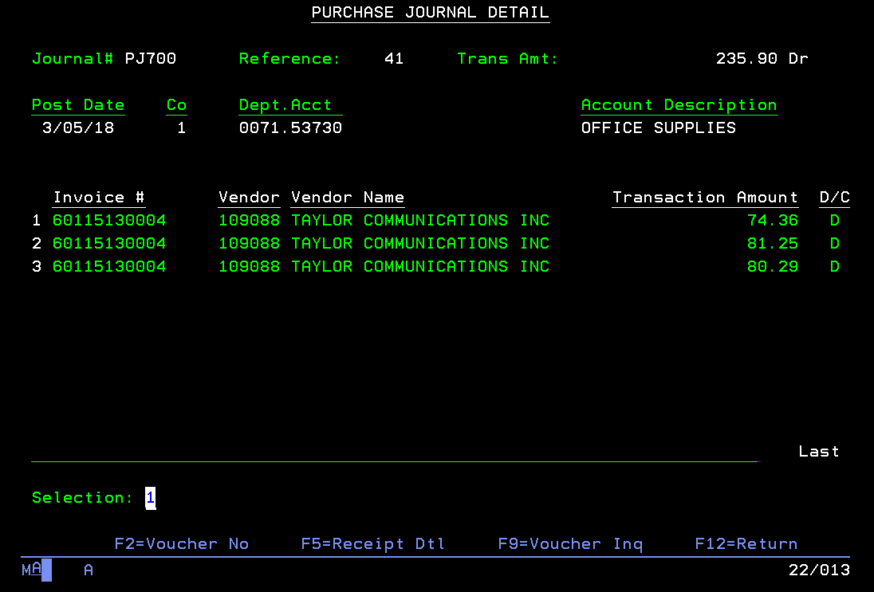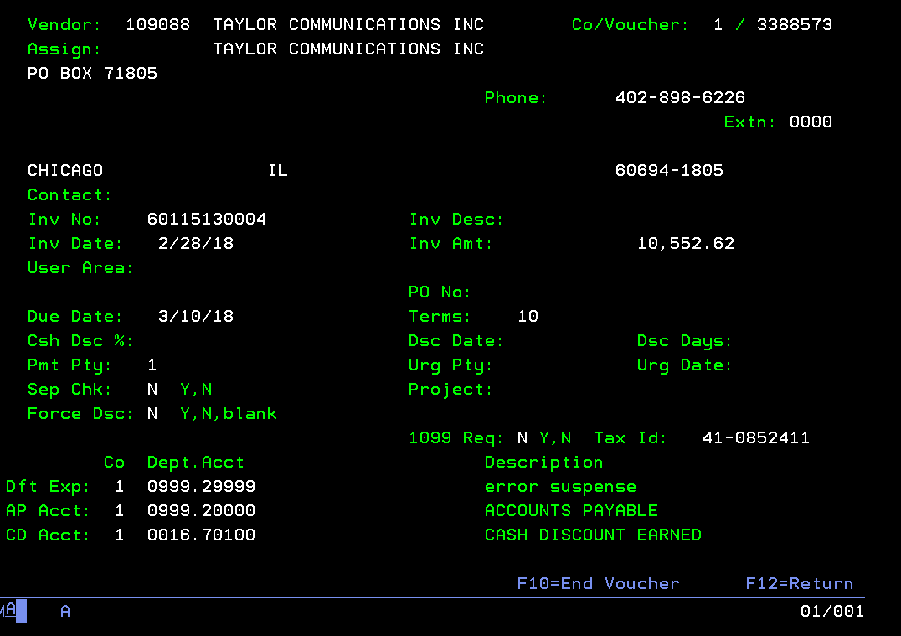
Once again, F3 and F12 are your friend. Use those function keys to back out of the screens.
**If you have additional questions at this point, contact accounting for a copy of the receipt.

